|  |
| --- |
| Stock Assessment Form  **Small Pelagics**  **Reference Year: 2016**  **Reporting Year: 2017** |
| [A brief abstract may be added here] |
|  |



Stock Assessment Form version 1.0 (January 2014)

Uploader: Please include your name

Stock assessment form

1. Basic Identification Data 3

2. Stock identification and biological information 5

2.1. Stock unit 5

2.2. Growth and maturity 6

3. Fisheries information 8

3.1. Description of the fleet 8

3.2. Historical trends 10

3.3. Management regulations 11

3.4. Reference points 12

4. Fisheries independent information 13

4.1. MEDIAS ACUSTIC SURVEY 13

4.1.1 Brief description of the chosen method and assumptions used 13

4.1.2. Spatial distribution of the resources 16

4.1.3. Historical trends 16

4.1.4. Sardine LFD from 2004 to 2016 for GSA 17 West, GSA18 West and East 17

5. Ecological information 20

5.1. Protected species potentially affected by the fisheries 20

5.2. Environmental indexes 20

6. Stock Assessment 21

6.1. SAM 21

6.1.1. Model assumptions 21

6.1.2. Scripts 21

6.1.3. Input data and Parameters 22

*Table 6.1.3.1. Catch numbers at age (in thousands) for the entire GSA17-18.* 22

*Table 6.1.3.2. Catch numbers at age (in thousands) for the acoustic survey in GSA 17 West + GSA 18 West-East.* 23

*Table 6.1.3.3. Catch numbers at age (in thousands) for the acoustic survey in GSA 17 East.* 24

6.1.4 Results 26

*Table 6.1.4. Results of the final FLSAM assessment of sardine in GSA17-18.* 26

*6.1.5 Robustness analysis* 30

6.1.6 Retrospective analysis, comparison between model runs, sensitivity analysis, etc. 30

*7. Assessment quality* 31

This assessment was prepared and presented also in STECF EWG 17 09. 31

Hereunder all the modifications introduced in this year assessment compared to the last year assessment are listed. 31

7. Stock Simulations 32

7.1. Short term predictions 32

7.2. Medium term predictions 32

7.3. Long term predictions 32

8. Draft scientific advice 33

8.1. Explanation of codes 34

# Basic Identification Data

|  |  |  |
| --- | --- | --- |
| **Scientific name:** | **Common name:** | **ISCAAP Group:** |
| *Sardina pilchardus* | Sardine | [ISCAAP Group] |
| **1st Geographical sub-area:** | **2nd Geographical sub-area:** | **3rd Geographical sub-area:** |
| GSA17 | GSA18 |  |
| **4th Geographical sub-area:** | **5th Geographical sub-area:** | **6th Geographical sub-area:** |
|  |  |  |
| **1st Country** | **2nd Country** | **3rd Country** |
| Italy | Croatia | Slovenia |
| **4th Country** | **5th Country** | **6th Country** |
| Albania | Montenegro |  |
| **Stock assessment method: (direct, indirect, combined, none)** | | |
| **SAM** | | |
| **Authors:** | | |
| Angelini S.1, Arneri E.2, Belardinelli A.1, Biagiotti I.1, Bratina P.5, Canduci G.1, Colella S.1, Costantini I.1, Croci C.1, De Felice A.1, Domenichetti F.1, Donato F.1, Gašparević D.3, Juretic T.3, Leonori I.1, Martinelli M.1, Milone N.2, Modic T.5, Pallaoro A.3, Panfili M.1, Pesic A.4, Ikica Z.4, Santojanni A.1,Tesauro C.1, Ticina V.3 | | |
| **Affiliation:** | | |
| 1 CNR – ISMAR (National Research Council - Institute of Marine Science) Ancona, Italy  2 FAO-AdriaMed, Rome, Italy  3 Institute of Oceanography and Fisheries, Croatia  4 Institute of Marine Biology, University of Montenegro, Kotor, Montenegro  5 Fisheries Research Institute of Slovenia | | |

The ISSCAAP code is assigned according to the FAO 'International Standard Statistical Classification for Aquatic Animals and Plants' (ISSCAAP) which divides commercial species into 50 groups on the basis of their taxonomic, ecological and economic characteristics. This can be provided by the GFCM secretariat if needed. A list of groups can be found here:

<http://www.fao.org/fishery/collection/asfis/en>

Indirect method (you can choose more than one):

* SAM

# Stock identification and biological information

## Stock unit

Although there is some evidence of differences on a series of morphometric, meristic, serological and ecological characteristics, the lack of genetic heterogeneity in the Adriatic stock has been demonstrated through allozymic and mitochondrial DNA (mtDNA) surveys (Carvalho *et al.*, 1994) and through sequence variation analysis of a 307-bp cytochrome b gene (Tinti *et al*., 2002). Also, Ruggeri *et al*. (2013) supports the hypothesis of one stock on the basis of microsatellites DNA, even if suggests that some of the genetic homogeneity observed could be apparent and the identification of a subtle structuring in sardine population could be limited by technical difficulties and by the incomplete knowledge of molecular mechanisms.

In light of these considerations and according to the fact that most of the Italian vessels registered in GSA 18 fish in GSA 17, even though landings occur in GSA18, it was decided to merge the two GSAs and thus carry out an assessment for sardine in GSA 17-18 (Figure 2.1.1).

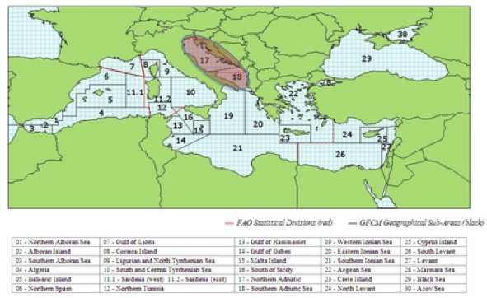

*Figure 2.1.1: Geographical location of GSAs 17 and 18.*

## Growth and maturity

According to the work done in 2014 on otolith reading, the growth parameters used in this assessment are the same, as well as the ALK from 2014 was used to calculate the numbers at age given the length frequency distribution of survey data for the whole data series up to 2014, whereas afterwards is calculated annually. Catch at age data were calculated using the ALK from 2014 up to 2014, whereas afterwards is calculated annually, using the methodology agreed.

Table 2.2.1: Maximum size, size at first maturity and size at recruitment.

|  |  |  |  |  |  |  |  |  |  |
| --- | --- | --- | --- | --- | --- | --- | --- | --- | --- |
| **Somatic magnitude measured**  **(LT, LC, etc)** | | |  | **Units** |  |  | | | |
| **Sex** | **Fem** | **Mal** | **Combined** | **Reproduction season** | **October-April** |  |  |  |  |
| **Maximum size observed** |  |  | 22 cm | **Recruitment season** |  |  | | | |
| **Size at first maturity** |  |  | 7-8 cm | **Spawning area** | Adriatic Sea, over continental shelf |  | | | |
| **Recruitment size to the fishery** |  |  | 10 cm | **Nursery area** | Adriatic Sea |  | | | |

Table 2.2.2: M vector and proportion of matures by size or age (Sex combined)

|  |  |  |
| --- | --- | --- |
| **Size/Age** | **Natural mortality** | **Proportion of matures** |
| *0* | *1.06* | *0.5* |
| *1* | *0.83* | *1* |
| *2* | *0.69* | *1* |
| *3* | *0.61* | *1* |
| 4 | 0.48 | 1 |

Table 2.2.3: Growth and length weight model parameters

|  |  |  |  |  |  |  |  |  |  |  |
| --- | --- | --- | --- | --- | --- | --- | --- | --- | --- | --- |
|  |  | |  |  |  | **Sex** | | | |  |
|  |  | | |  | **Units** | **female** | **male** | **Combined** | **Years** |  |
| **Growth model** | | **L∞** | | | cm |  |  | 19.8 | 2014 |  |
| **K** | | | y-1 |  |  | 0.38 | 2014 |  |
| **t0** | | | y |  |  | -1.785 | 2014 |  |
| **Data source** | | | DCF | | | | |  |
| **Length weight** **relationship** | | **a** | | |  |  |  | 0.0058 |
| **b** | | |  |  |  | 3.119 |
|  |  | **M**  (scalar) | | |  |  |  |  |
|  |  | **sex ratio** (% females/total) | | |  |  |  |  |  | |

# Fisheries information

## Description of the fleet

Sardines are fished by purse seiners and pelagic trawlers belonging to Italy, Croatia and, to a much smaller extent, Slovenia, Albania and Montenegro.

The Italian fleet is composed of about 65 pairs of mid-water trawlers and about 20 purse seiners (with quite different tonnage), with the former being predominant on the latter ones. Most of the Italian boats whose port of registry is located in GSA 18 actually fish and land in GSA 17. Croatia has about 270 active purse seiners targeting small pelagic (mainly sardine) while in Slovenia only 3 purse seiners are currently active. In Montenegro most of the catches are originated from small-scale beach seine fisheries and from small purse seiners fisheries in coastal waters (< 70 m depth).

Exploitation is based on all the age classes from 0 to 4+.

The Croatian catches of sardine represent the great part of the total catches, while the Italian small pelagic fishery concentrate mainly on anchovy (though high amounts were caught by the Italian fleet in the past).

Table 3.1.1: Description of operational units exploiting the stock in 2016

|  |  |  |  |  |  |  |  |
| --- | --- | --- | --- | --- | --- | --- | --- |
|  |  | **Country** | **GSA** | **Fleet Segment** | **Fishing Gear Class** | **Group of Target Species** | **Species** |
|  |  |
| **ITA_PTM_1718** | | Italy | GSA17-18 | PTM_0640 | Pelagic Trawler | Small pelagic | *E. encrasicolus*  *S. pilchardus*  *Mugilidae* spp. |
| **ITA_PS_17 18** | | Italy | GSA17-18 | PS_0640 | Purse seiners | Small pelagic | *E. encrasicolus*  *S. pilchardus*  *Mugilidae* spp. |
| **HRV_PS_17** | | Croatia | GSA17 | PS_0640 | Purse seiners | Small pelagic | *E. encrasicolus*  *S. pilchardus* |
| **SLO_PS_17** | | Slovenia | GSA17 | PS_1218 | Purse seiners | Small pelagic | *E. encrasicolus*  *S. pilchardus* |
| **ALB_18** | | Albania | GSA18 |  | Purse seiners | Small pelagic | *E. encrasicolus*  *S. pilchardus* |
| **MNE_18** | | Montenegro | GSA18 | PS_0624 | Purse seiners | Small pelagic | *E. encrasicolus*  *S. pilchardus* |

Table 3.1.2: Catch, bycatch, discards and effort by operational unit in the reference year (2016)

|  |  |  |  |  |  |  |
| --- | --- | --- | --- | --- | --- | --- |
| **Operational Units\*** | **Fleet**  **(n° of boats)\*** | **Catch (T or kg of the species assessed)** | **Other species caught (names and weight )** | **Discards** **(species assessed)** | **Discards** **(other species caught)** | **Effort (units)** |
| ITA_PTM_1718 | 135* | 24,092 |  | < 1% |  |  |
| ITA_PS_1718 | 23* |  | < 1% |  |  |
| HRV_PS_17 | 279* | 54,274 |  | < 1% |  |  |
| SLO_PS_17 | 3* | 27 |  | < 1% |  |  |
| ALB_PS_18 |  | 890 |  | < 1% |  |  |
| MNE_PS_18 |  | 122 |  | < 1% |  |  |
| **Total** | 440 | 79405 |  |  |  |  |

*DCF effort data 2016

## Historical trends

In figure 3.2.1 the trend in landings from 1975 to 2016 for the Eastern Adriatic (Croatia, Slovenia, Albania and Montenegro) and the western Adriatic (Italy, GSA17-18) is shown. Slovenian, Albania and Montenegrin catches are on the overall low (around 1000 tonnes in 2016). Albania and Montenegro landings were assumed as a fixed percentage of Croatian catches before, respectively, 2006 and 2007. The catch of sardine in GSA17 and 18 started decreasing in the late eighties reaching a minimum in 2006 with 20,475 tonnes. In the last 10 years the Eastern catches grew high, reaching the maximum of the entire time series in 2014 with about 61,000 tons (~73% of the overall catches). The total catches in 2016 are 79,405 tonnes. The average of the last three years (2013-2015) is equal to 79,985 tons.

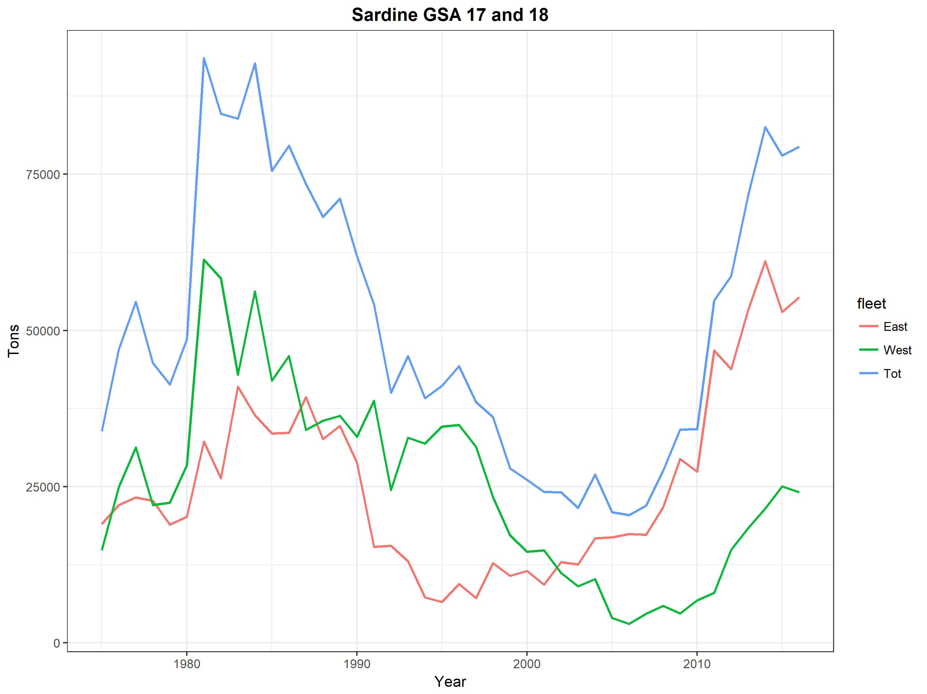

*Figure 3.2.1: Total Adriatic catch of sardine for the whole period assessed (1975-2016) for the Eastern side (red line), the Western side (green line) and the total catch (blue line) of GSA17-18.*

In figure 3.2.2 the trend in the cohorts of the total catches is shown.

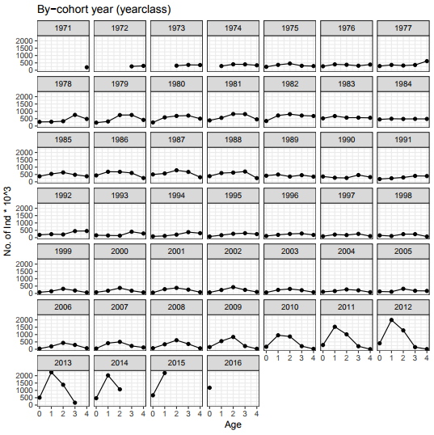

*Figure 3.2.2* *Catch-at-age cohort plots for GSA 17 -18 sardine.*

## Management regulations

A multi–annual management plan for small pelagic fisheries in the Adriatic Sea has been established by the General Fisheries Commission for the Mediterranean in 2012 (GFCM/37/2013/1). In particular, the plan establishes “a temporal closure period of no less than 15 continuous days for each vessels fishing small pelagic stocks in GSA 17 in order to protect nursery and spawning areas. This closure shall be designated in waters under the jurisdiction and shall take place between 1 April and 31 August” (GFCM/38/2014/1). Moreover, for year 2015 it was decided that “each fishing vessel targeting anchovy shall not exceed 144 fishing days per year” (GFCM/38/2014/1). In addition, in 2016 the GFCM Recommendation (REC.CM-GFCM/40/2016/3) established further emergency measures for the small pelagic stocks in the Adriatic Sea. In particular, the plan establishes “a temporal closure period of no less than 15 continuous days and up to 30 continuous days for sardine from the 1st of October to 31st of March, and for anchovy from the 1st of April to the 30th of September. Also, additional closures for vessels over 12 m length overall for no less than 6 months, which shall cover at least 30 percent of the area which has been identified as nursery area or area important for the protection of early age classes of fish (in territorial and inner sea), are expected.

Regarding the closure period, Italy has been enforcing for years a general regulation concerning the fishing gears and since 1988 a suspension (about 42 days) of fishing activity of pelagic trawlers and purse seiners has implemented in summer. In Croatia from 2013 management plan for purse seiners “srdelara” has been endorsed. A closure period is observed from the 1st December to the 31st January (except period 14th-24th December) and 1st-31st of May from the Croatian purse seiners. In 2011 and 2012 the closure season for the Italian fleet was extended to 60 days (August and September). Also, since 2015 spatial closures in inner sea were endorsed in the Croatian fishing ground for the fishing vessels above 12 m. In Montenegro a closure period of 15 days was observed from the first to the 15th of April, whereas in Slovenia from 17th of March to 15th of April.

## Reference points

Table 3.3-1: List of reference points and empirical reference values previously agreed (if any)

|  |  |  |  |  |  |
| --- | --- | --- | --- | --- | --- |
| **Indicator** | **Limit Reference point/empirical reference value** | **Value** | **Target Reference point/empirical reference value** | **Value** | **Comments** |
| **B** |  |  |  |  |  |
| **SSB** | Blim | 125,318 | Bpa | 250,636 | 2015 GFCM benchmark assessment |
| **F** |  |  | Fmsy | 0.715 | 2015 GFCM benchmark assessment |
| **Y** |  |  |  |  |  |
| **CPUE** |  |  |  |  |  |
| **Index of Biomass at sea** |  |  |  |  |  |

# Fisheries independent information

## 4.1. MEDIAS ACUSTIC SURVEY

### 4.1.1 Brief description of the chosen method and assumptions used

Italian acoustic survey was carried out since 1976 in the Northern Adriatic Sea (half of the western area) and since 1987 also in the Mid and Southern Adriatic Sea (the other half of the western area). Since 2007 even Slovenia was included in the western acoustic survey estimations. Since 2009 the MEDIAS (MEDIterranean Acoustic Surveys) project entered in the EC Data Collection framework.

Since 2008, and with exception of 2009, the Eastern GSA 18 (Montenegro and Albania waters) was monitored by Italian acoustic survey group in collaboration with local Institutes.

The eastern part of GSA 17 (except Slovenia) was covered by Croatian national pelagic monitoring program (i.e. acoustic survey) PELMON since 2004. Since 2013 this acoustic survey has been carried out within EU MEDIAS framework.

Estimates from acoustic surveys were included in the assessment model considering three tuning indexes:

1. The data from the surveys in GSA 17 West and whole GSA 18 in the form of numbers-at-age from 2004 to 2016. A revised 2014 ALK, following the guidelines of AdriaMed workshop (Split, April 2015) have been used to split the number at length into numbers at age for the 2004 to 2014 in the western part of GSA 17 and GSA 18. For the 2015 and 2016 new ALK is produced each year;
2. Acoustic survey East, that includes the eastern side of GSA 17 in the form of numbers-at-age from 2013 to 2016. ALKs from survey on the eastern part of GSA 17 were obtained yearly, on the basis of age readings following the same guidelines of before mentioned AdriaMed workshop (Split, April 2015).
3. Acoustic survey East biomass, that includes the eastern side of GSA 17 in the form of total biomass from 2003 to 2012.

The survey results have been aggregated as follows:

* Western GSA 17 + Western GSA 18 + Eastern GSA 18;
* Eastern GSA 17.

For the purpose of this assessment, these two indices of abundance have been considered separately. The rationale behind it is to be found in the fact that the same boat and the same crew covers the whole Western GSA 17 and the whole GSA 18, while the Eastern part of GSA 17 is carried out on a different vessel, also a different net was used in the past (2004-2008) following the procedure described by Leonori et al. (2012).

Due to the different time series available for the Western and Eastern GSA 18 (GSA 18 West started in 2005, GSA 18 East started in 2008) an average proportion over the years was calculated to estimate the biomass in the Eastern GSA 18 for the years 2004-2007.

When length frequency distributions were missing, the length structure was assumed equal to the one in the following year.

The revised 2014 ALK have been used to split the numbers at length into numbers at age for the entire time series, except for Eastern GSA 17 in which numbers at age for the period 2013-2015 were obtained using annual survey’s ALKs based on direct age reading from otoliths. Otoliths from Eastern GSA 17 survey collected during 2013 and 2014 were re-analysed according to outcomes from AdriaMed Study Group on intercalibration of sardine otolith reading and revision of criteria in the Adriatic Sea (Split, Croatia, 8-10 April 2015).

The standardized methodology followed during MEDIAS surveys are given in the MEDIAS handbook (MEDIAS, April 2016) revised annually (MEDIAS Steering Committee report, 2016).

**Direct methods: acoustics**

1. **GSA 17 WEST + GSA 18 WEST-EAST**

Table 4.1.1.1: Acoustic cruise information.

|  |  |  |  |  |
| --- | --- | --- | --- | --- |
| **Date** | From the 21st of May to 27th June 2016 (North and South Adriatic: Italy, Slovenia, Montenegro and Albania) | | | |
| **Cruise** | MEDIAS Adriatic GSA 17 and GSA 18 | | **R/V** | Dallaporta |
| **Target species** | | Anchovy, Sardine | | |
| **Sampling strategy** | | Parallel grid of transects perpendicular to the coastline | | |
| **Sampling season** | | Spring - Summer | | |
| **Investigated depth range (m)** | | 10-200 m | | |
| **Echo-sounder** | | Simrad EK60 | | |
| **Fish sampler** | | Pelagic trawl | | |
| **Cod –end mesh size as opening (mm)** | | 18 | | |
| **ESDU (i.e. 1 nautical mile)** | | 1 nautical mile | | |
| **TS (Target Strength)/species** | | Anchovy b20: -74.6; Sardine b20: -72.5 | | |
| **Software used in the post-processing** | | Echoview | | |
| **Samples (gear used)** | | Samples of anchovy, sardine and other pelagic species (secondary in occurrence) caught by means of pelagic trawl | | |
| **Biological data obtained** | | Anchovy and sardine numerical abundance and biomass by nautical mile and by total area; anchovy and sardine spatial distribution in numbers and biomass | | |
| **Age slicing method** | | Age-length key by otolith reading | | |
| **Maturity ogive used** | | Macroscopic gonad identification | | |

Table 4.1.1.2: Abundance at age (in thousands) from acoustic survey for the years 2004-2016.

|  |  |  |  |  |  |
| --- | --- | --- | --- | --- | --- |
| **Year** | **Age 0** | **Age 1** | **Age 2** | **Age 3** | **Age 4** |
| **2004** | 642614 | 1725618 | 1431214 | 1003905 | 51410 |
| **2005** | 438061 | 1264847 | 553052 | 602318 | 30814 |
| **2006** | 575220 | 1546199 | 1508479 | 1322416 | 124118 |
| **2007** | 917720 | 3037743 | 2110423 | 1366099 | 115372 |
| **2008** | 3804458 | 9049691 | 3399879 | 1684309 | 69607 |
| **2009** | 2366576 | 8322660 | 1581468 | 472427 | 71727 |
| **2010** | 2098915 | 6683795 | 2567964 | 758027 | 45771 |
| **2011** | 9879725 | 22828960 | 5757835 | 928614 | 13170 |
| **2012** | 9918526 | 11204898 | 1550743 | 282387 | 78442 |
| **2013** | 8229421 | 22055507 | 3897769 | 198738 | 4112 |
| **2014** | 2533931 | 17129516 | 4427857 | 167082 | 0 |
| **2015** | 3628719 | 10139650 | 5675860 | 324310 | 0 |
| **2016** | 5470972 | 4659918 | 1008994 | 67985 | 15760 |

### Spatial distribution of the resources

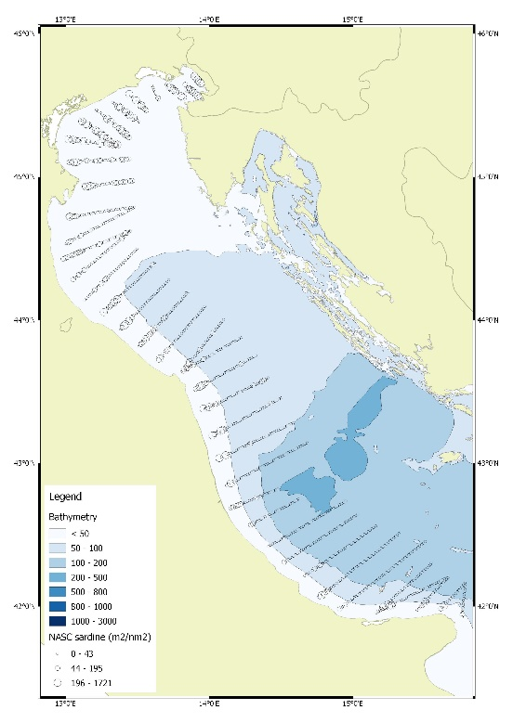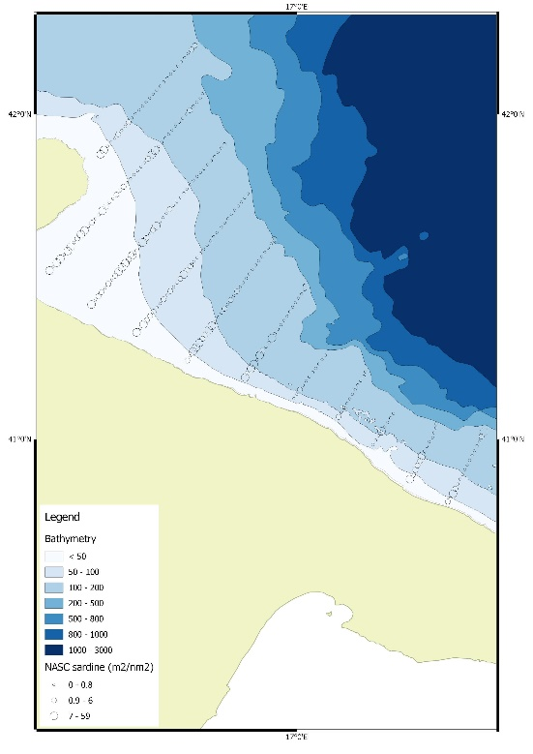

*Figure 4.1.2.1. NASC Sardine for GSA 17 and GSA 18 West acoustic survey 2016.*

### Historical trends

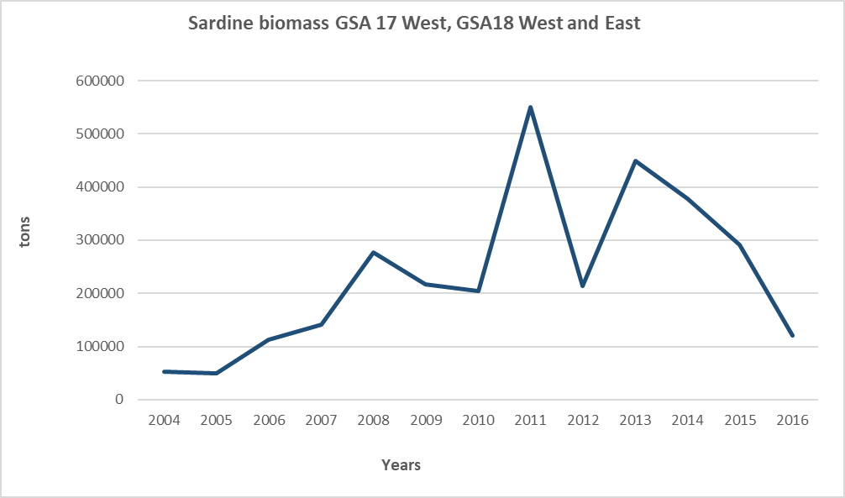

*Figure 4.1.3.1. Biomass (t) of sardine in the Western GSA 17 and Western and Eastern GSA 18 from acoustic surveys carried out from 2004 to 2016.*

### Sardine LFD from 2004 to 2016 for GSA 17 West, GSA 18 West and East

In the plot below the length frequency distributions observed in the acoustic survey for the three areas (GSA 17 West, GSA 18 East and GSA 18 West) from 2004 to 2016 are shown (Figure 4.1.4.1).

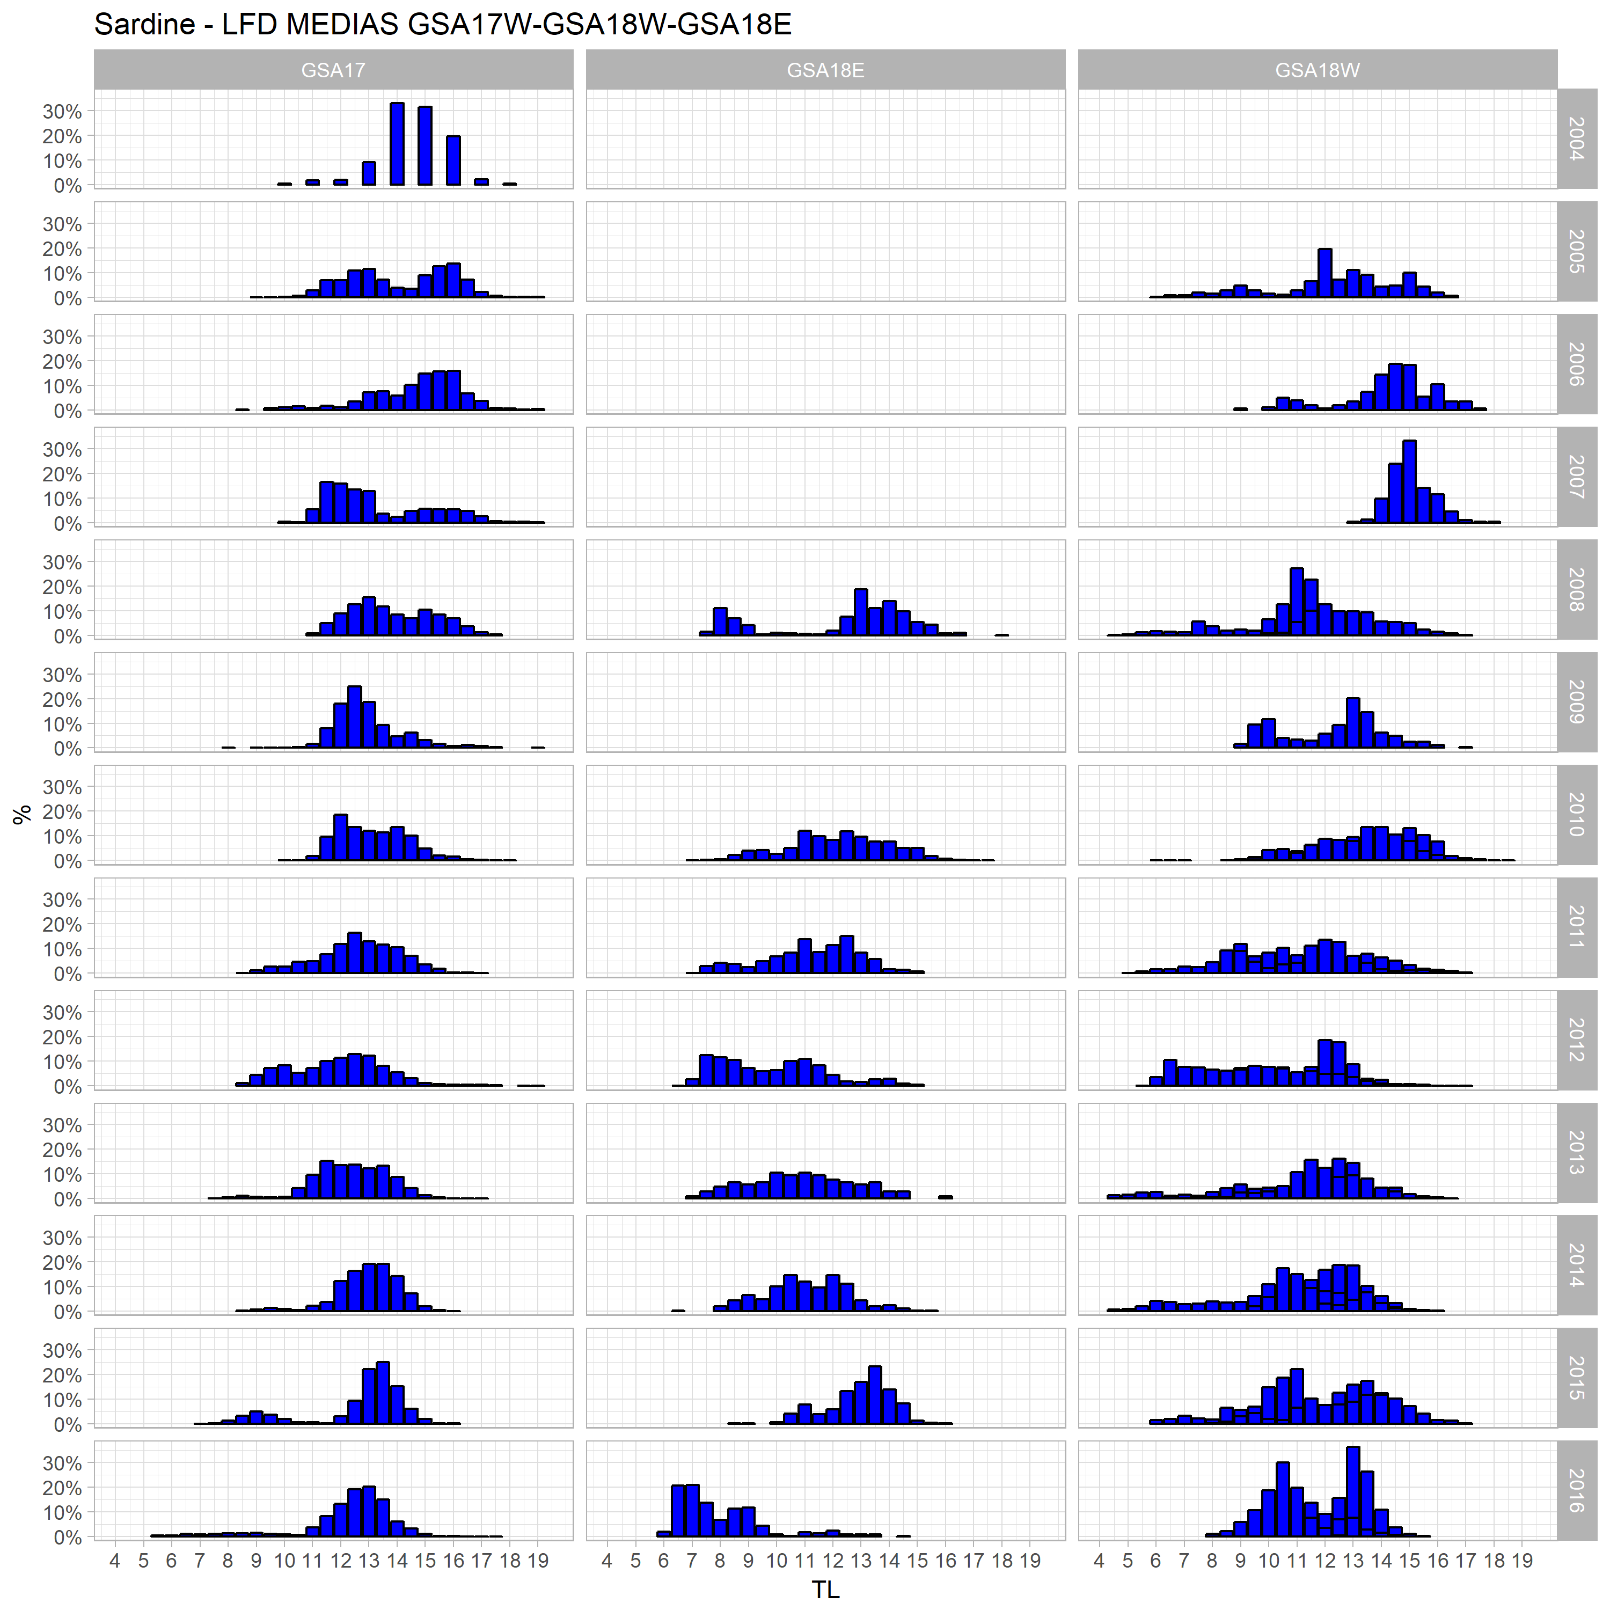

*Figure 4.1.4.1. LFD observed in the acoustic survey for GSA 17 West, GSA 18 West and GSA 18 East from 2004 to 2016.*

1. **GSA 17 EAST**
2. Table 4.1.1.4: Acoustic cruise information.

|  |  |  |  |  |
| --- | --- | --- | --- | --- |
| **Date** | 24 August – 22 September 2016 | | | |
| **Cruise** | MEDIAS GSA 17 East | | **R/V** | BIOS DVA |
| **Target species** | | Anchovy, Sardine | | |
| **Sampling strategy** | | Partially random; parallel transects in open sea and transects adapted to geomorphology in inner sea | | |
| **Sampling season** | | September | | |
| **Investigated depth range (m)** | | 7 - 200 | | |
| **Echo-sounder** | | SIMRAD EK60 (38 kHz) | | |
| **Fish sampler** | | Pelagic trawl | | |
| **Cod –end mesh size as opening (mm)** | | 18 mm (with cod-end cover as used in sardine fry fishery - 4 mm) | | |
| **ESDU (i.e. 1 nautical mile)** | | 1 nautical mile | | |
| **TS (Target Strength)/species** | | Sardine b20: -72.6 | | |
| **Software used in the post-processing** | | Myriax Echoview | | |
| **Samples (gear used)** | | Samples of anchovy, sardine and other pelagic species (secondary in occurrence) caught by means of pelagic trawl | | |
| **Biological data obtained** | | Anchovy and sardine numerical abundance and biomass by nautical mile and by total area; anchovy and sardine spatial distribution in numbers and biomass | | |
| **Age slicing method** | | Age-length key by otolith reading | | |
| **Maturity ogive used** | | Macroscopic gonad identification | | |

The table below (Table 4.1.5.1) shows the number at age for the acoustic survey for the eastern GSA17 area from 2013-2016 (figure 4.1.4.2).

Table 4.1.1.5: Abundance at age (in thousands) from acoustic survey for the years 2013-2016.

|  |  |  |  |
| --- | --- | --- | --- |
| **Year** | **Age 0** | **Age 1** | **Age 2** |
| **2013** | 4717909.8 | 3853279.6 | 3031 |
| **2014** | 1180050.3 | 4323384.2 | 64747 |
| **2015** | 12993118.3 | 2446709.9 | 3505 |
| **2016** | 13332270 | 709729 | 1515.5 |

**Spatial distribution of the resources**

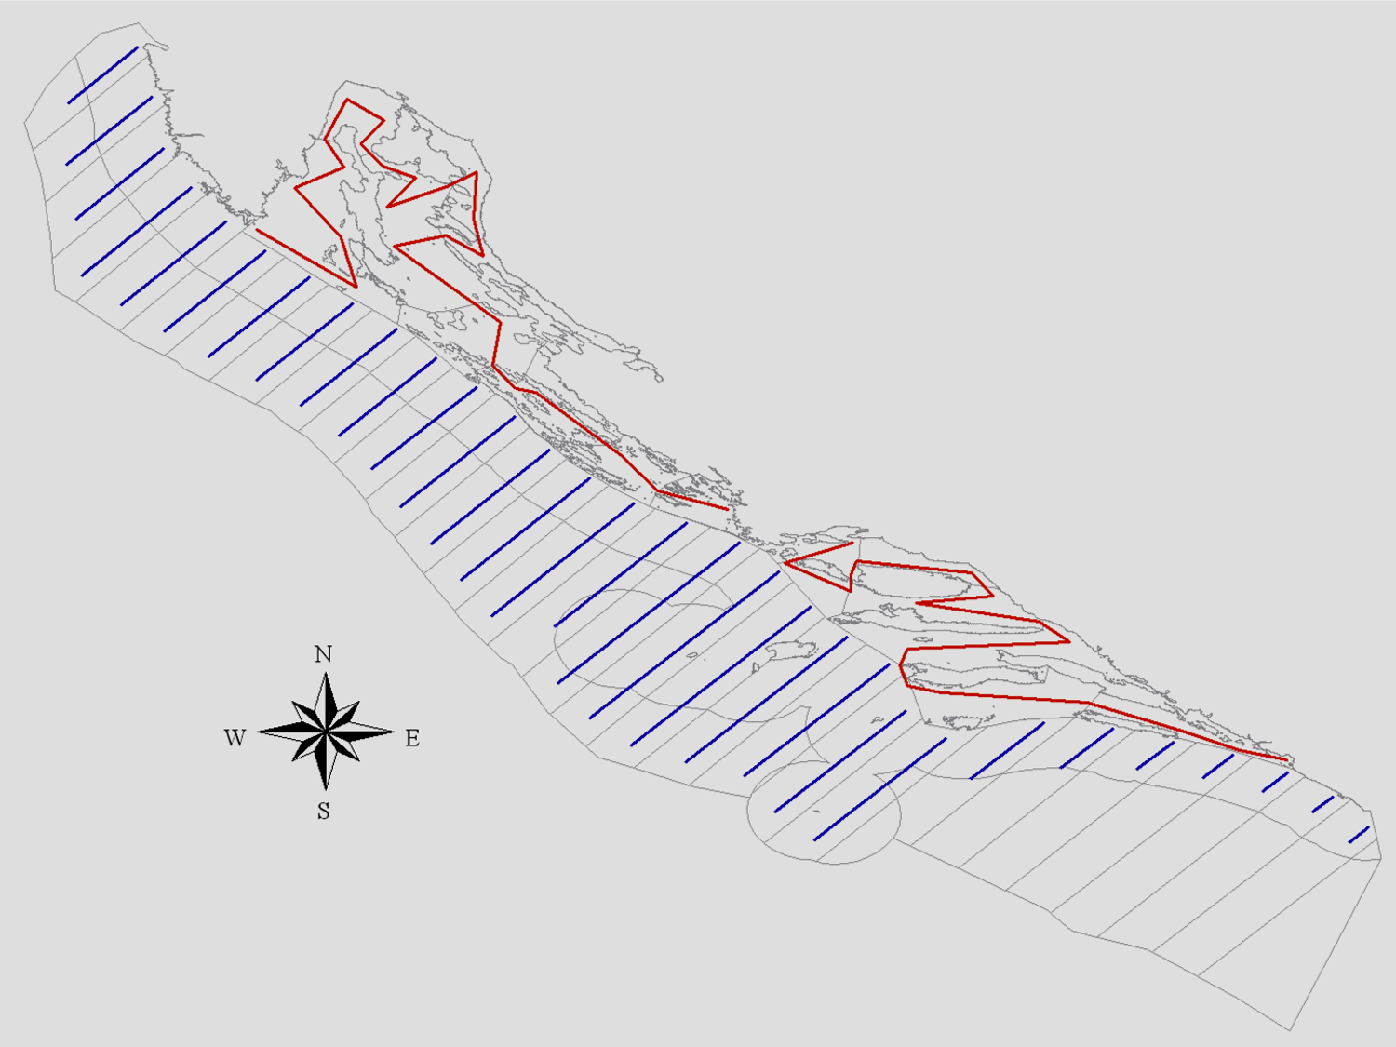

*Figure 4.1.4.2. Acoustic sampling transects in GSA17-East: parallel transects in open sea (blu lines) and transects adapted to geomorphology in inner sea (red lines).*

**Historical trends**

Figure 4.1.4.3 shows the biomass trend for the East Echosurvey from 2003 to 2012. This time series was also included in the stock assessment model. These data represent the only valid information coming from this survey for these years, thus it was decided to include the biomass by year as third tuning index. However, in 2011 and 2012 the echosuvey was not carried out for the entire area, thus the total estimates are estimated.

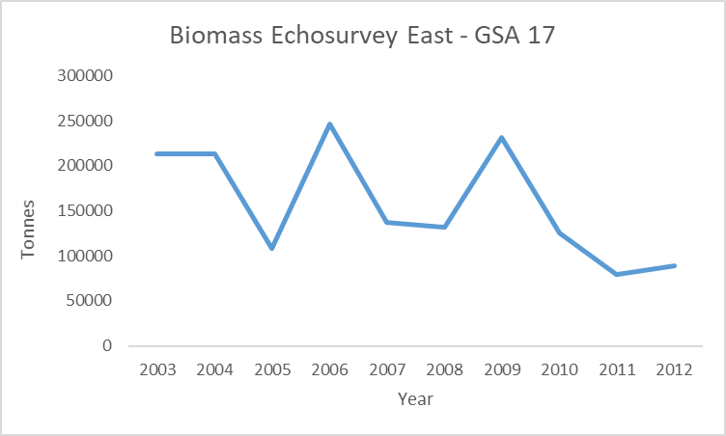

Figure 4.1.4.3. Biomass (tonnes) of sardine in the Eastern side of GSA 17 estimated from the acoustic surveys carried out from years 2003 to 2012.

**Sardine LFD from 2013 to 2016 for East Echosurvey GSA 17**

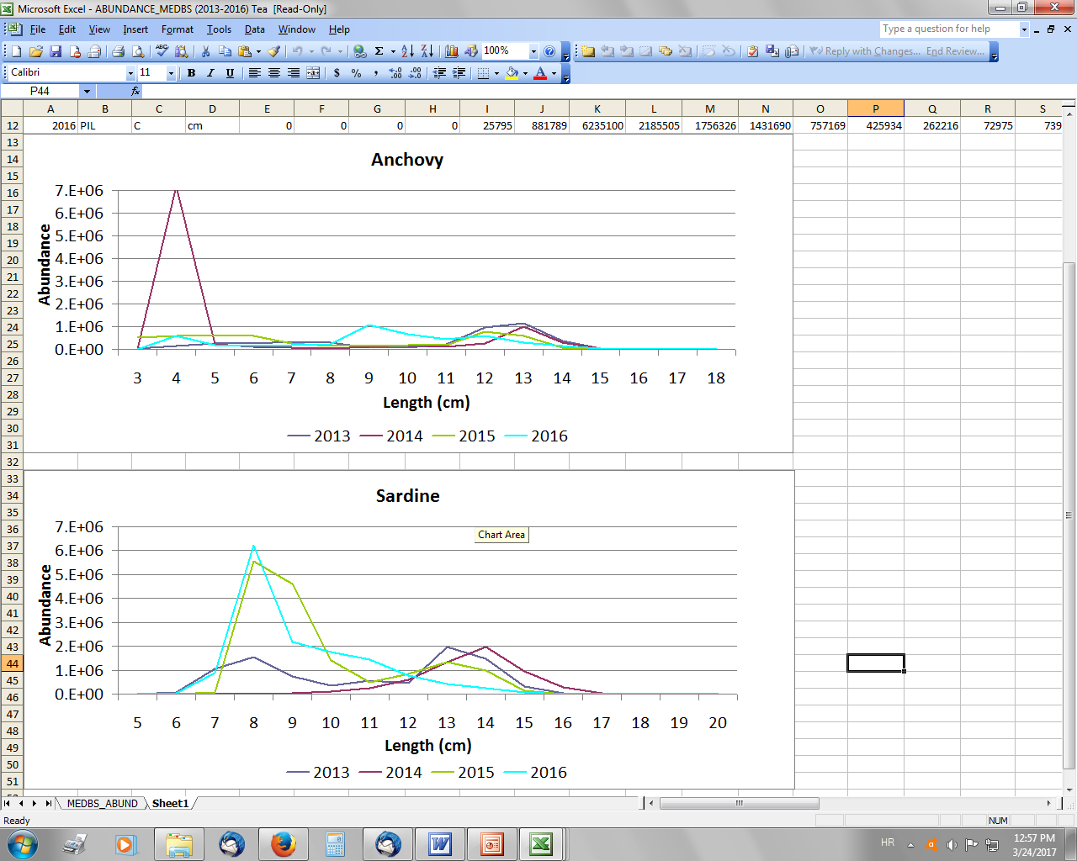

Figure 4.1.4.3. LFD of sardine abundance estimates from MEDIAS in GSA17-East.

# Ecological information

## Protected species potentially affected by the fisheries

N/A

## Environmental indexes

N/A

# Stock Assessment

## SAM

### Model assumptions

State-Space Assessment Program (SAM) has been performed to assess the stock status of sardine in GSA 17-18 from 1975 to 2016.

Acoustic surveys data were available and used as tuning indices.

The SAM environment is encapsulated into the Fisheries Library in R (FLR) (Kell *et al*., 2007) in the form of the package “FLSAM”. The state-space assessment model (SAM) is an assessment model, which is used for several assessments within ICES. The model allows selectivity to evolve gradually over time. It has fewer model parameters than full parametric statistical assessment models, with quantities such as recruitment and fishing mortality modelled as random effects.

Estimates from acoustic surveys were included in the assessment model considering three tuning indexes:

1. The data from the surveys in GSA 17 West, GSA 18 west and GSA 18 East in the form of numbers-at-age from 2004 to 2016. A revised 2014 ALK, following the guidelines of AdriaMed workshop (Split, April 2015) have been used to split the number at length into numbers at age for the 2004 to 2014 in the western part of GSA 17 and GSA 18. For the 2015 and 2016 new ALK is produced each year;
2. Acoustic survey East, that includes the eastern side of GSA 17 in the form of numbers-at-age from 2013 to 2016. ALKs from survey on the eastern part of GSA 17 were obtained on the basis of age readings following the same guidelines of before mentioned AdriaMed workshop;
3. Acoustic survey East biomass, that includes the eastern side of GSA 17 in the form of total biomass from 2003 to 2012.

All assessments are performed with version 0.99-3 of FLSAM, together with version 2.5 of the FLR library (FLCore).

### Scripts

An object of class "FLSAM.control"

Slot "range":

min max plusgroup minyear maxyear minfbar maxfbar

0 4 4 1975 2016 1 3

Slot "fleets":

catch EchoWest17-18 EchoEast17 East Biomass

0 2 2 3

Slot "plus.group":

plusgroup

TRUE

Slot "states":

age

0 1 2 3 4

catch 1 2 3 4 4

Slot "logN.vars":

Age

0 1 2 3 4

1 2 2 2 2

Slot "catchabilities":

age

fleet 0 1 2 3 4

EchoWest17-18 1 2 3 4 5

EchoEast17 6 7 8 NA NA

Slot "f.vars":

age

fleet 0 1 2 3 4

catch 1 1 1 2 2

Slot "obs.vars":

age

fleet 0 1 2 3 4

catch 1 2 3 4 4

EchoWest17-18 5 6 7 7 8

EchoEast17 9 10 11 NA NA

### Input data and Parameters

### *Table 6.1.3.1. Catch numbers at age (in thousands) for the entire GSA17-18.*

|  |  |  |  |  |  |  |  |  |  |  |
| --- | --- | --- | --- | --- | --- | --- | --- | --- | --- | --- |
| **Catch numbers at age (thousands)** | | | | | | | | | | |
| **Age** | **1975** | **1976** | **1977** | **1978** | **1979** | **1980** | **1981** | **1982** | **1983** | **1984** |
| **0** | 231022.9 | 267995.8 | 282511.3 | 280357.4 | 229090.2 | 245252.7 | 381863.4 | 341979.4 | 521857.9 | 449281.6 |
| **1** | 283396.9 | 364272.7 | 397544.8 | 361673.6 | 287281 | 311915.8 | 590103.1 | 557087.2 | 716120.1 | 678101.6 |
| **2** | 309248.4 | 402305.8 | 452105.2 | 371067.5 | 319110.3 | 327207.9 | 746419.3 | 686194.7 | 820504.2 | 809503.2 |
| **3** | 261505.3 | 363465.6 | 397068.5 | 301658.2 | 305273.8 | 358515.6 | 758172.9 | 752245.9 | 710606.1 | 812475.3 |
| **4** | 199913.7 | 296803.1 | 352147.8 | 333945.2 | 282414.7 | 383437.5 | 616913.4 | 481193.2 | 416684.2 | 500248.7 |
|  |  |  |  |  |  |  |  |  |  |  |
| **Age** | **1985** | **1986** | **1987** | **1988** | **1989** | **1990** | **1991** | **1992** | **1993** | **1994** |
| **0** | 378927.9 | 435926.7 | 502774.1 | 386307.9 | 416516.4 | 362614.6 | 188902.5 | 188196.4 | 158560.9 | 88310.9 |
| **1** | 494820.3 | 540285.9 | 687007.9 | 570319.2 | 597292.5 | 495757.6 | 277885.6 | 241577.4 | 234442.1 | 147916.1 |
| **2** | 571134.1 | 482560.3 | 640284.8 | 679412.9 | 786328.1 | 628339.3 | 358623.6 | 265605 | 297275.5 | 215913.9 |
| **3** | 712743.7 | 570811.9 | 486214.1 | 481061.8 | 603348.5 | 674664.2 | 701200.1 | 453118.2 | 462078.2 | 402172.6 |
| **4** | 453202.5 | 680315.3 | 558572.5 | 483827.5 | 378259.4 | 259922.8 | 312931.2 | 254541.4 | 354022.2 | 321444.3 |
|  |  |  |  |  |  |  |  |  |  |  |
| **Age** | **1995** | **1996** | **1997** | **1998** | **1999** | **2000** | **2001** | **2002** | **2003** | **2004** |
| **0** | 77377.2 | 111004.4 | 92446.9 | 152648.3 | 81158.4 | 81512.7 | 56292.9 | 70298.2 | 67021.4 | 110638.3 |
| **1** | 115543.1 | 167095.3 | 190835.3 | 209162.4 | 109389.5 | 150802.4 | 186400.4 | 289735.4 | 237182.7 | 241222 |
| **2** | 135497.7 | 205702.9 | 265853.4 | 254400.4 | 174552 | 238859 | 316794.8 | 376286.9 | 379031.1 | 431203.5 |
| **3** | 443962 | 401591 | 376411.5 | 305339.4 | 279739.9 | 259156.3 | 237756.1 | 200252.5 | 185226.9 | 259503.6 |
| **4** | 392925.3 | 450721.4 | 281167 | 302554 | 241390.9 | 185158.5 | 102042.6 | 75504.7 | 64796.4 | 69602.5 |
|  |  |  |  |  |  |  |  |  |  |  |
| **Age** | **2005** | **2006** | **2007** | **2008** | **2009** | **2010** | **2011** | **2012** | **2013** | **2014** |
| **0** | 132093.9 | 43670.4 | 50620.7 | 72541.6 | 150162.4 | 169687.7 | 288048.8 | 405130.8 | 504501.3 | 466091.8 |
| **1** | 162145.1 | 114109.7 | 198980 | 416636.7 | 337891.6 | 553657.8 | 952090.1 | 1531999 | 1994905 | 2237694 |
| **2** | 309528.6 | 272860.1 | 318630 | 433896.9 | 503045.3 | 613610 | 836096.7 | 868708 | 1015291 | 1284031 |
| **3** | 244969.2 | 219861.2 | 213443.9 | 180955.2 | 293697.8 | 225009.4 | 361420.7 | 218559.8 | 211498.8 | 205666 |
| **4** | 84154.8 | 101188.3 | 83242.6 | 84931.3 | 170478.8 | 67682.7 | 120453.9 | 63672.5 | 34976.9 | 29425.7 |
|  |  |  |  |  |  |  |  |  |  |  |
| **Age** | **2015** | **2016** |  |  |  |  |  |  |  |  |
| **0** | 663116.7 | 1178434.6 |  |  |  |  |  |  |  |  |
| **1** | 2024641 | 2185911.6 |  |  |  |  |  |  |  |  |
| **2** | 1382301.9 | 1070666.7 |  |  |  |  |  |  |  |  |
| **3** | 145520 | 160412.9 |  |  |  |  |  |  |  |  |
| **4** | 6174.3 | 9727.1 |  |  |  |  |  |  |  |  |

### *Table 6.1.3.2. Catch numbers at age (in thousands) for the acoustic survey in GSA 17 West + GSA 18 West-East.*

|  |  |  |  |  |  |  |
| --- | --- | --- | --- | --- | --- | --- |
| **Catch numbers at age (thousands) - Acoustic Survey GSA 17 WEST + GSA 18 WEST-EAST** | | | | | |  |
| **Age** | **2004** | **2005** | **2006** | **2007** | **2008** | **2009** |
| **0** | 642614 | 438061 | 575220 | 917720 | 3804458 | 2366576 |
| **1** | 1725618 | 1264847 | 1546199 | 3037743 | 9049691 | 8322660 |
| **2** | 1431214 | 553052 | 1508479 | 2110423 | 3399879 | 1581468 |
| **3** | 1003904 | 602318 | 1322415 | 1366099 | 1684309 | 472427 |
| **4** | 51410 | 30814 | 124118 | 115372 | 69607 | 71727 |
|  |  |  |  |  |  |  |
| **Age** | **2010** | **2011** | **2012** | **2013** | **2014** | **2015** |
| **0** | 2098915 | 9879725 | 10517702 | 8229421 | 2533931 | 3628719 |
| **1** | 6683795 | 22828960 | 10746318 | 22055507 | 17129516 | 10139650 |
| **2** | 2567964 | 5757835 | 1425598 | 3897768 | 4427857 | 5675860 |
| **3** | 758027 | 928614 | 266937 | 198738 | 167082 | 324310 |
| **4** | 45771 | 13170 | 78442 | 4112 | 0 | 0 |
|  |  |  |  |  |  |  |
| **Age** | **2016** |  |  |  |  |  |
| **0** | 5470972 |  |  |  |  |  |
| **1** | 4659918 |  |  |  |  |  |
| **2** | 1008994 |  |  |  |  |  |
| **3** | 67985 |  |  |  |  |  |
| **4** | 15760 |  |  |  |  |  |

### *Table 6.1.3.3. Catch numbers at age (in thousands) for the acoustic survey in GSA 17 East.*

|  |  |  |  |  |
| --- | --- | --- | --- | --- |
| **Catch numbers at age (thousands) - Acoustic Survey GSA 17 EAST** | | | | |
| **Age** | **2013** | **2014** | **2015** | **2016** |
| **0** | 4717909.8 | 1180050.3 | 12993118 | 13332270 |
| **1** | 3853279.6 | 4323384.2 | 2446710 | 709729 |
| **2** | 3031 | 64747 | 3505 | 1515.5 |

The following plots show the internal between year consistency of the age classes in the catch (6.1.3.1.) and in the tuning indices (6.1.3.2. and 6.1.3.3.).

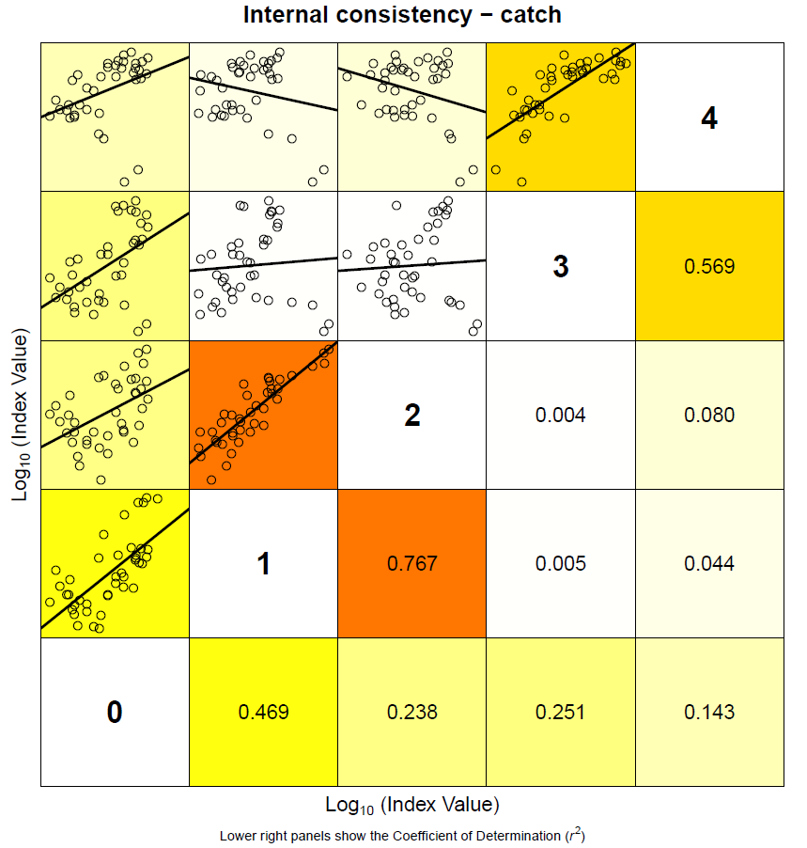

*Figure 6.1.3.1. Catch at age data (numbers at age) between-year consistency plot for GSA 17 West-East and GSA 18 West-East sardine.*

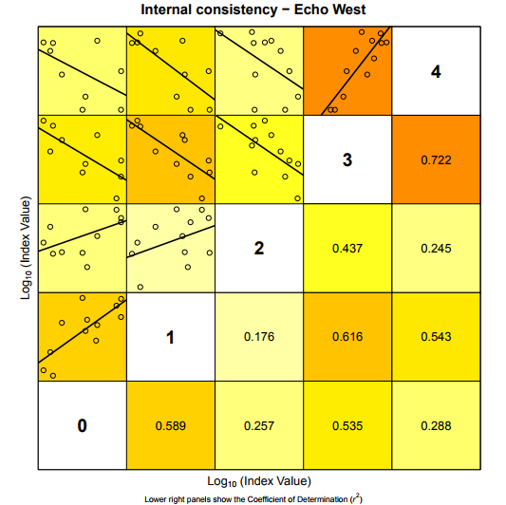

*Figure 6.1.3.2. MEDIAS acoustic survey index between-year consistency plot for GSA 17 West and GSA18 West-East sardine.*

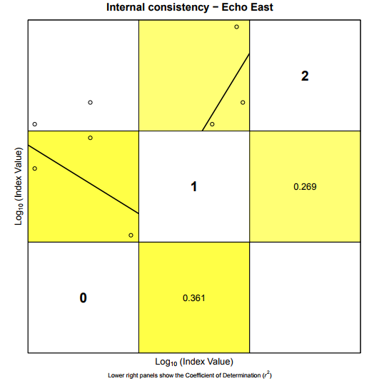

*Figure 6.1.3.3. MEDIAS acoustic survey index between-year consistency plot for GSA 17 East sardine.*

### 6.1.4 Results

The average fishing mortality for ages 1-3 (presented in figure 6.1.4.1, middle) shows a constant increase from the beginning of the time series (Fbar1-3=0.09 in 1975) up to 2014, when reach the maximum value of 1.683, to then describe a small decrease reaching the value of 1.30 in 2016.

The spawning stock biomass (figure 6.1.4.1, top) fluctuates from the highest values in the early eighties (SSB in 1982= 762,990 tons) to a minimum in 2001 of 121,176 tonnes. The stock starts slowly to recover afterwards. The 2015 and 2016 estimates are equal to respectively 173,165 and 161,297.

The recruitment (age 0 – figure 6.1.4.1, bottom) follows the trend of the SSB, showing however a stronger recover in the last decade. After a big peak in the early eighties (54,843,816 thousands) and a minimum in 1999 (9,820,671 thousands), the recruitment shows a quite constant increase reaching the values of 24,791,217 thousands in 2016.

### *Table 6.1.4. Results of the final FLSAM assessment of sardine in GSA17-18.*

|  |  |  |  |  |  |  |  |  |
| --- | --- | --- | --- | --- | --- | --- | --- | --- |
| **Year** | **Recruits Age 0 (Thousands) Mean** | **Recruits Age 0 (Thousands) Low** | **Recruits Age 0 (Thousands) High** | **Total biomass (tonnes) Mean** | **Total biomass (tonnes) Low** | **Total biomass (tonnes) High** | | |
| 1975 | 37393221 | 31145094 | 44894808 | 829020.4 | 726350.7 | 946202.4 |  |  |
| 1976 | 38339835 | 32431461 | 45324600 | 869783.8 | 767564.3 | 985616.4 |  |  |
| 1977 | 37655892 | 32065202 | 44221340 | 882046.5 | 783462.8 | 993035 |  |  |
| 1978 | 40669948 | 34836002 | 47480898 | 861990.9 | 771192.7 | 963479.5 |  |  |
| 1979 | 45993011 | 39523413 | 53521618 | 908000.3 | 818326 | 1007501 |  |  |
| 1980 | 51238410 | 44035889 | 59618977 | 1011556 | 915351.6 | 1117871 |  |  |
| 1981 | 54843816 | 47163690 | 63774573 | 1141667 | 1035816 | 1258335 |  |  |
| 1982 | 53169740 | 45782604 | 61748809 | 1156606 | 1049698 | 1274401 |  |  |
| 1983 | 41741233 | 36164792 | 48177535 | 1053891 | 961570.3 | 1155076 |  |  |
| 1984 | 32999402 | 28618022 | 38051566 | 949793.6 | 872025 | 1034498 |  |  |
| 1985 | 30768439 | 26783503 | 35346266 | 799706.4 | 737317.4 | 867374.7 |  |  |
| 1986 | 33733434 | 29434387 | 38660379 | 795717.9 | 734422.6 | 862128.9 |  |  |
| 1987 | 38763902 | 33671035 | 44627083 | 738222.1 | 679372.9 | 802169 |  |  |
| 1988 | 39864629 | 34418267 | 46172826 | 759184.4 | 694195.1 | 830257.9 |  |  |
| 1989 | 37095269 | 31851977 | 43201683 | 759184.4 | 690536.6 | 834656.7 |  |  |
| 1990 | 32736460 | 28071116 | 38177171 | 718556.8 | 651242.5 | 792828.8 |  |  |
| 1991 | 29769651 | 25575993 | 34650937 | 677388.3 | 613784 | 747583.8 |  |  |
| 1992 | 26695351 | 22999277 | 30985399 | 625308.2 | 568143.1 | 688225.2 |  |  |
| 1993 | 20645336 | 17822366 | 23915451 | 580706.1 | 530997.3 | 635068.2 |  |  |
| 1994 | 18201235 | 15775382 | 21000123 | 514525.3 | 473187.6 | 559474.2 |  |  |
| 1995 | 15263883 | 13308633 | 17506390 | 439327.3 | 406790 | 474467.1 |  |  |
| 1996 | 12942150 | 11333958 | 14778532 | 373622 | 348236.8 | 400857.8 |  |  |
| 1997 | 10501199 | 9202522 | 11983148 | 320295.7 | 299765 | 342232.6 |  |  |
| 1998 | 9889657 | 8673780 | 11275973 | 250446.3 | 235070.1 | 266828.4 |  |  |
| 1999 | 9820671 | 8637637 | 11165736 | 250446.3 | 233965.6 | 268088.1 |  |  |
| 2000 | 10659904 | 9388848 | 12103035 | 196614.5 | 183931.5 | 210171.9 |  |  |
| 2001 | 12385042 | 10899074 | 14073605 | 226386.7 | 210117.5 | 243915.7 |  |  |
| 2002 | 12800567 | 11256026 | 14557048 | 256273.4 | 236853.3 | 277285.7 |  |  |
| 2003 | 11570855 | 10165505 | 13170491 | 226613.2 | 210495.9 | 243964.6 |  |  |
| 2004 | 11398587 | 9996471 | 12997366 | 231885.7 | 215517.2 | 249497.5 |  |  |
| 2005 | 11432835 | 10016881 | 13048943 | 197797.7 | 183718.3 | 212956 |  |  |
| 2006 | 11617231 | 10236800 | 13183813 | 264078.1 | 244519.5 | 285201 |  |  |
| 2007 | 13203599 | 11691518 | 14911240 | 292728.3 | 271321.5 | 315823.9 |  |  |
| 2008 | 14048132 | 12445334 | 15857350 | 350810 | 324503.9 | 379248.6 |  |  |
| 2009 | 14768395 | 13138309 | 16600728 | 279288.3 | 261156.2 | 298679.4 |  |  |
| 2010 | 16110793 | 14388550 | 18039182 | 314582 | 293608.4 | 337053.8 |  |  |
| 2011 | 19077115 | 17094703 | 21289420 | 371758.6 | 346685.4 | 398645.2 |  |  |
| 2012 | 22342472 | 20031022 | 24920649 | 405144.9 | 377004.8 | 435385.4 |  |  |
| 2013 | 24058526 | 21474207 | 26953855 | 441971.2 | 410570.1 | 475773.9 |  |  |
| 2014 | 20999307 | 17918704 | 24609531 | 438888.2 | 398819.3 | 482982.7 |  |  |
| 2015 | 21943905 | 16717583 | 28804103 | 480220.2 | 394895.4 | 583981 |  |  |
| 2016 | 24791217 | 17083766 | 35975935 | 495835.7 | 364099.5 | 675236 |  |  |
|  |  |  |  |  |  |  |  |  |
| **Year** | **Spawing biomass (tonnes) Mean** | **Spawing biomass (tonnes) Low** | **Spawing biomass (tonnes) High** | **Landings (tonnes) Mean** | **Landings (tonnes) Low** | **Landings (tonnes) High** | | |
| 1975 | 566935 | 490784.1 | 654901.6 | 34098.2 | 32465.76 | 35812.73 |  |  |
| 1976 | 589482.3 | 516217 | 673146 | 46816.92 | 44594.71 | 49149.87 |  |  |
| 1977 | 606827.6 | 534160.2 | 689380.7 | 54230.57 | 51635.91 | 56955.61 |  |  |
| 1978 | 561293.9 | 497189.7 | 633663.3 | 44712.13 | 42553.35 | 46980.41 |  |  |
| 1979 | 585956 | 524306 | 654855.1 | 41689.31 | 39646.09 | 43837.83 |  |  |
| 1980 | 637302.7 | 575116.2 | 706213.3 | 49118.94 | 46652.3 | 51716 |  |  |
| 1981 | 741180.9 | 671068.2 | 818618.9 | 92134.06 | 87666.61 | 96829.18 |  |  |
| 1982 | 762989.8 | 689944 | 843769.2 | 85135.55 | 81033.97 | 89444.74 |  |  |
| 1983 | 753135.2 | 682561.6 | 831005.8 | 83616.82 | 79677.37 | 87751.05 |  |  |
| 1984 | 709276 | 646903.6 | 777662.2 | 92134.06 | 87747.92 | 96739.45 |  |  |
| 1985 | 584200.8 | 535394.1 | 637456.7 | 75735.33 | 72041.28 | 79618.8 |  |  |
| 1986 | 505346.7 | 465788.8 | 548264.2 | 79062.98 | 75080.25 | 83256.97 |  |  |
| 1987 | 451350.7 | 416484.6 | 489135.7 | 72984.33 | 69505.61 | 76637.16 |  |  |
| 1988 | 476393.8 | 436607.5 | 519805.6 | 68459.66 | 65227.03 | 71852.51 |  |  |
| 1989 | 499318.8 | 454606.1 | 548429.2 | 70898.18 | 67582.57 | 74376.44 |  |  |
| 1990 | 489921.3 | 442990.3 | 541824.2 | 61512.77 | 58548.11 | 64627.54 |  |  |
| 1991 | 468832.1 | 422856.6 | 519806.4 | 54122.21 | 51338.27 | 57057.13 |  |  |
| 1992 | 438888.2 | 396341.3 | 486002.5 | 40336.01 | 38304.65 | 42475.11 |  |  |
| 1993 | 435826.7 | 395970.6 | 479694.5 | 45524.23 | 43211.84 | 47960.36 |  |  |
| 1994 | 386930.4 | 353774.3 | 423193.9 | 39261.51 | 37188.94 | 41449.59 |  |  |
| 1995 | 332368.6 | 306013.4 | 360993.8 | 41150.86 | 38806.27 | 43637.09 |  |  |
| 1996 | 281813.3 | 261386 | 303836.9 | 43870.61 | 41462.8 | 46418.25 |  |  |
| 1997 | 242316.5 | 225911.5 | 259912.8 | 38445.62 | 36528.35 | 40463.52 |  |  |
| 1998 | 181316.6 | 169996.9 | 193390 | 35667.67 | 33860.99 | 37570.75 |  |  |
| 1999 | 163898.1 | 153187.4 | 175357.6 | 28113.35 | 26698.01 | 29603.73 |  |  |
| 2000 | 127388.9 | 119388 | 135926 | 26081.98 | 24801.3 | 27428.79 |  |  |
| 2001 | 121176.1 | 113305.2 | 129593.7 | 24221.6 | 23050.65 | 25452.03 |  |  |
| 2002 | 132190.6 | 122871 | 142217.1 | 24028.6 | 22866.53 | 25249.72 |  |  |
| 2003 | 139804.5 | 129793.3 | 150587.8 | 21781.15 | 20691.28 | 22928.42 |  |  |
| 2004 | 141775.5 | 132135.2 | 152119.1 | 26608.87 | 25258.92 | 28030.98 |  |  |
| 2005 | 128027.5 | 118830.3 | 137936.5 | 20768.65 | 19729.02 | 21863.06 |  |  |
| 2006 | 139804.5 | 129645.3 | 150759.7 | 20640.28 | 19613.81 | 21720.48 |  |  |
| 2007 | 139664.7 | 130374.6 | 149616.9 | 22026.47 | 20954.49 | 23153.28 |  |  |
| 2008 | 151297 | 141712.5 | 161529.7 | 27474.13 | 26138.97 | 28877.48 |  |  |
| 2009 | 152207.5 | 142867.1 | 162158.5 | 33894.23 | 32284.26 | 35584.48 |  |  |
| 2010 | 148746.7 | 140049.5 | 157983.9 | 34406.47 | 32652.79 | 36254.34 |  |  |
| 2011 | 158102.7 | 149419.5 | 167290.5 | 54339.14 | 51628.26 | 57192.36 |  |  |
| 2012 | 161781.2 | 152449.5 | 171684.1 | 58688.55 | 55461.06 | 62103.87 |  |  |
| 2013 | 184609.9 | 173700.4 | 196204.5 | 71682.36 | 67577.84 | 76036.19 |  |  |
| 2014 | 203414.3 | 190278.9 | 217456.4 | 82619.42 | 77814.02 | 87721.57 |  |  |
| 2015 | 173165 | 154970.1 | 193496.1 | 78198.05 | 73434.18 | 83270.97 |  |  |
| 2016 | 161296.6 | 126490.3 | 205680.5 | 78354.6 | 72678.2 | 84474.35 |  |  |
|  |  |  |  |  |  |  |  |  |
| **Year** | **Yield / SSB (ratio) Mean** | **Yield / SSB (ratio) Low** | **Yield / SSB (ratio) High** | **Mean F ages 2-6 Mean** | **Mean F ages 2-6 Low** | **Mean F ages 2-6 High** | **Mean F ages 0-1** | **SoP (%)** |
| 1975 | 0.060145 | 0.066151 | 0.054684 | 0.087039 | 0.073855 | 0.102576 | 0.020418 | 1 |
| 1976 | 0.07942 | 0.086388 | 0.073015 | 0.111515 | 0.095512 | 0.130198 | 0.026778 | 1 |
| 1977 | 0.089367 | 0.096667 | 0.082619 | 0.126742 | 0.10907 | 0.147277 | 0.028464 | 1 |
| 1978 | 0.079659 | 0.085588 | 0.074141 | 0.110759 | 0.095835 | 0.128007 | 0.026633 | 1 |
| 1979 | 0.071148 | 0.075616 | 0.066943 | 0.098401 | 0.085938 | 0.112672 | 0.019882 | 1 |
| 1980 | 0.077073 | 0.081118 | 0.07323 | 0.114109 | 0.100508 | 0.129551 | 0.018976 | 1 |
| 1981 | 0.124307 | 0.130637 | 0.118284 | 0.214445 | 0.189834 | 0.242248 | 0.029879 | 1 |
| 1982 | 0.111582 | 0.11745 | 0.106006 | 0.195167 | 0.172002 | 0.221452 | 0.028056 | 1 |
| 1983 | 0.111025 | 0.116733 | 0.105596 | 0.182939 | 0.161931 | 0.206673 | 0.037947 | 1 |
| 1984 | 0.129899 | 0.135643 | 0.124398 | 0.193922 | 0.172475 | 0.218035 | 0.047153 | 1 |
| 1985 | 0.129639 | 0.134557 | 0.124901 | 0.173427 | 0.15542 | 0.19352 | 0.044821 | 1 |
| 1986 | 0.156453 | 0.161189 | 0.151856 | 0.210957 | 0.189979 | 0.234252 | 0.050542 | 1 |
| 1987 | 0.161702 | 0.166886 | 0.156679 | 0.253017 | 0.228737 | 0.279873 | 0.055874 | 1 |
| 1988 | 0.143704 | 0.149395 | 0.13823 | 0.273351 | 0.246314 | 0.303354 | 0.041204 | 1 |
| 1989 | 0.14199 | 0.148662 | 0.135617 | 0.293875 | 0.262785 | 0.328644 | 0.041473 | 1 |
| 1990 | 0.125556 | 0.132166 | 0.119278 | 0.236762 | 0.209793 | 0.267198 | 0.037705 | 1 |
| 1991 | 0.115441 | 0.121408 | 0.109766 | 0.198414 | 0.173958 | 0.226308 | 0.024731 | 1 |
| 1992 | 0.091905 | 0.096646 | 0.087397 | 0.137793 | 0.121056 | 0.156844 | 0.023273 | 1 |
| 1993 | 0.104455 | 0.109129 | 0.099981 | 0.155284 | 0.137261 | 0.175674 | 0.024558 | 1 |
| 1994 | 0.101469 | 0.105121 | 0.097945 | 0.138069 | 0.122682 | 0.155387 | 0.020274 | 1 |
| 1995 | 0.123811 | 0.126812 | 0.12088 | 0.15812 | 0.141203 | 0.177064 | 0.018258 | 1 |
| 1996 | 0.155673 | 0.158627 | 0.152774 | 0.219984 | 0.19796 | 0.244458 | 0.030184 | 1 |
| 1997 | 0.158659 | 0.161693 | 0.155681 | 0.236478 | 0.215145 | 0.259927 | 0.040257 | 1 |
| 1998 | 0.196715 | 0.199186 | 0.194274 | 0.292059 | 0.267621 | 0.318729 | 0.054803 | 1 |
| 1999 | 0.17153 | 0.174283 | 0.168819 | 0.316922 | 0.290579 | 0.345653 | 0.032921 | 1 |
| 2000 | 0.204743 | 0.207737 | 0.201792 | 0.420332 | 0.387264 | 0.456224 | 0.040065 | 1 |
| 2001 | 0.199888 | 0.203439 | 0.196399 | 0.453691 | 0.417912 | 0.492533 | 0.043655 | 1 |
| 2002 | 0.181772 | 0.186102 | 0.177544 | 0.453677 | 0.417115 | 0.493444 | 0.054682 | 1 |
| 2003 | 0.155797 | 0.159417 | 0.152259 | 0.390956 | 0.357961 | 0.426992 | 0.045801 | 1 |
| 2004 | 0.187683 | 0.19116 | 0.18427 | 0.406716 | 0.372709 | 0.443825 | 0.053422 | 1 |
| 2005 | 0.16222 | 0.166027 | 0.158501 | 0.354942 | 0.324157 | 0.388652 | 0.039615 | 1 |
| 2006 | 0.147637 | 0.151288 | 0.144074 | 0.338917 | 0.308283 | 0.372595 | 0.026507 | 1 |
| 2007 | 0.15771 | 0.160725 | 0.15475 | 0.330748 | 0.301979 | 0.362256 | 0.040871 | 1 |
| 2008 | 0.181591 | 0.184451 | 0.178775 | 0.362366 | 0.335209 | 0.391724 | 0.072879 | 1 |
| 2009 | 0.222684 | 0.225974 | 0.219443 | 0.574457 | 0.534264 | 0.617674 | 0.062314 | 1 |
| 2010 | 0.231309 | 0.233152 | 0.229481 | 0.50513 | 0.471032 | 0.541696 | 0.09756 | 1 |
| 2011 | 0.343695 | 0.345526 | 0.341874 | 0.908679 | 0.859491 | 0.960683 | 0.156692 | 1 |
| 2012 | 0.362765 | 0.3638 | 0.361733 | 1.012831 | 0.960461 | 1.068055 | 0.222649 | 1 |
| 2013 | 0.388291 | 0.389048 | 0.387535 | 1.170007 | 1.112649 | 1.230322 | 0.252596 | 1 |
| 2014 | 0.406163 | 0.408947 | 0.403398 | 1.682516 | 1.613502 | 1.754481 | 0.262618 | 1 |
| 2015 | 0.451581 | 0.47386 | 0.43035 | 1.399745 | 1.261625 | 1.552986 | 0.294588 | 1 |
| 2016 | 0.48578 | 0.574575 | 0.410707 | 1.300346 | 0.917473 | 1.842996 | 0.321046 | 1 |

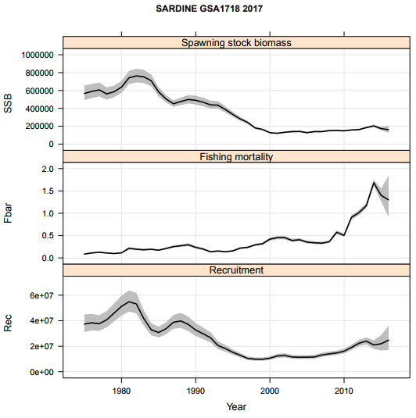

*Figure 6.1.4.1. Sardine results from SAM model: SSB, F and recruitment estimates.*

### *6.1.5 Robustness analysis*

### 6.1.6 Retrospective analysis, comparison between model runs, sensitivity analysis, etc.

Due to the very short time series of the tuning indexes (2013-2016 for the Echosurvey East), the retrospective analysis was run on 1 year only. The outputs are shown in Figure 6.1.6.1. and describe a rather consistent behavior of the assessment model, with the only exception of the slight variability and uncertainty in F estimate in the last year.

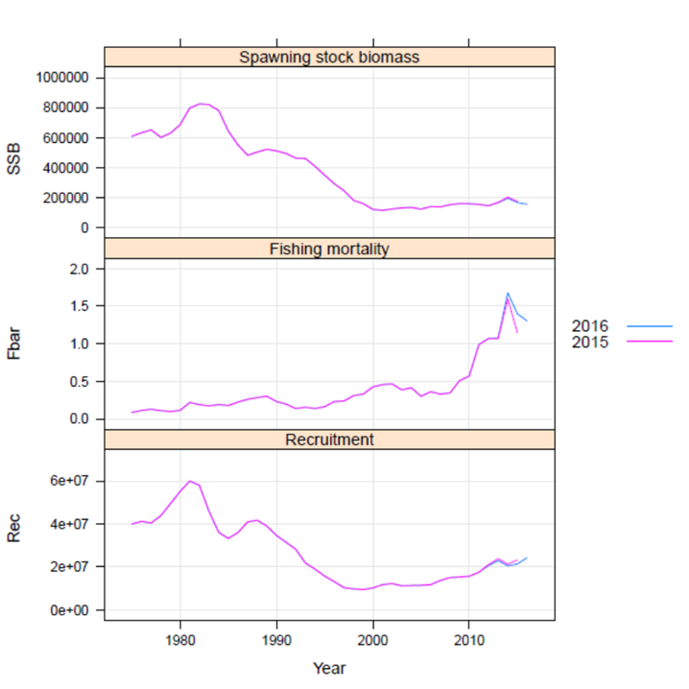

*Figure 6.1.6.1. FLSAM retrospective patterns for currently accepted assessment.*

The weight given to the input data is shown in the plot below: a higher weight is given to the catch data, followed by the Echosurvey East biomass. The age compositions from the account for a high variance (Figure *6.1.6.2.*).

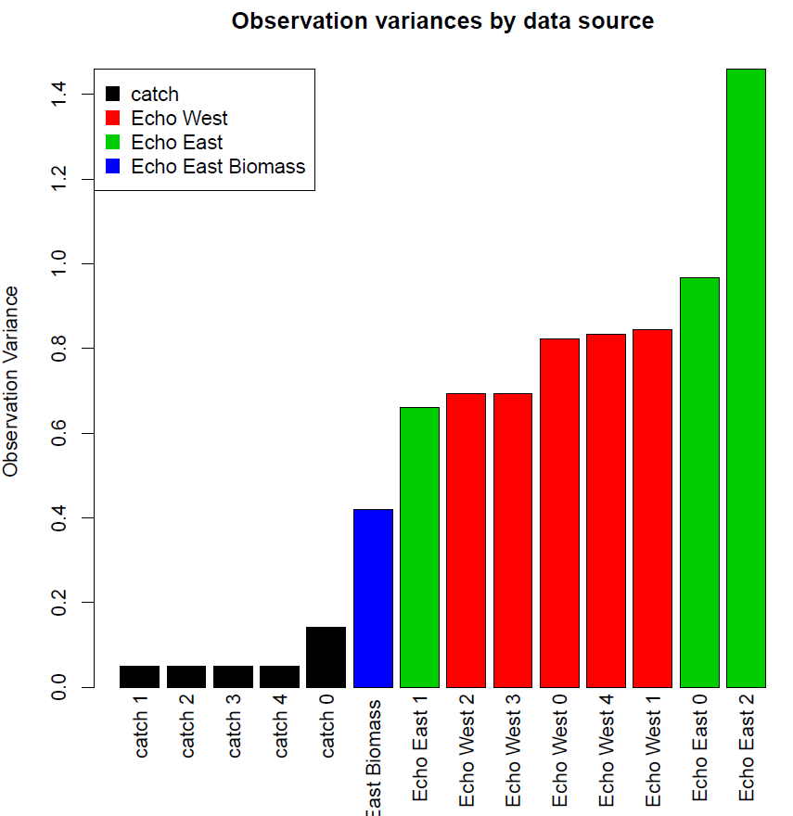

*Figure 6.1.6.2. Observation variances by data source of sardine in GSA17-18.*

### *7. Assessment quality*

### This assessment was prepared and presented also in STECF EWG 17 09.

### Hereunder all the modifications introduced in this year assessment compared to the last year assessment are listed.

1. Taking in account the advices of the expert, the time series of the East Echosurvey was reduced from years 2013 to 2016. Also, new numbers at age data were provided.
2. In agreement with the data availability and their validity, the biomass estimates for years from 2003 to 2012 for the East Echosurvey were added as a third tuning index.
3. About the reference points, some criticism was expressed in the use of the EqSim routine, thus this year it was decided to use the Patterson’s criterion (E=F/Z=0.4) as precautionary fishing mortality reference point, whereas Blim and Bpa were estimated by empirical approach and assumed equal to the last year assessment.

# Stock Simulations

## Short term predictions

## Medium term predictions

## Long term predictions

# Draft scientific advice

|  |  |  |  |  |  |  |
| --- | --- | --- | --- | --- | --- | --- |
| **Based on** | **Indicator** | **Analytic al reference point**  **(name and value)** | **Current value from the analysis**  **(name and value)** | **Empirical reference value**  **(name and value)** | **Trend**  **(time period)** | **Status** |
| **Fishing mortality** | Fishing mortality | Fmsy= 0.715 | Fcur = 1.30 |  | I | IOH |
|  | Fishing effort |  |  |  | D |  |
|  | Catch |  |  |  |  |  |
|  |  |  |  |  |  |  |
| **Stock abundance** | Biomass |  |  |  |  |  |
|  | SSB | Blim=125,318  Bpa=250,636 | Bcur=161,297 |  | D | OL |
| **Recruitment** |  |  |  |  | C |  |
| **Final Diagnosis** | | In overexploitation and overexploited | | | | |

Fcurrent is above FMSY and Bcurrent is below Bpa. Therefore, the stock is to be considered in overexploitation and overexploited.

## Explanation of codes

**Trend categories**

1. N - No trend
2. I - Increasing
3. D – Decreasing
4. C - Cyclic

**Stock Status**

**Based on Fishing mortality related indicators**

1. **N - Not known or uncertain** – Not much information is available to make a judgment;
2. **U - undeveloped or new fishery** - Believed to have a significant potential for expansion in total production;
3. **S - Sustainable exploitation**- fishing mortality or effort below an agreed fishing mortality or effort based Reference Point;
4. **IO –In Overfishing status**– fishing mortality or effort above the value of the agreed fishing mortality or effort based Reference Point. An agreed range of overfishing levels is provided;

**Range of Overfishing levels based on fishery reference points**

In order to assess the level of overfishing status when F0.1 from a Y/R model is used as LRP, the following operational approach is proposed:

* If Fc*/F0.1 is below or equal to 1.33 the stock is in **(OL): Low overfishing**
* If the Fc/F0.1 is between 1.33 and 1.66 the stock is in **(OI): Intermediate overfishing**
* If the Fc/F0.1 is equal or above to 1.66 the stock is in **(OH): High overfishing**

*Fc is current level of F

1. **C- Collapsed**- no or very few catches;

**Based on Stock related indicators**

1. **N - Not known or uncertain:** Not much information is available to make a judgment
2. **S - Sustainably exploited:** Standing stock above an agreed biomass based Reference Point;
3. **O - Overexploited**: Standing stock below the value of the agreed biomass based Reference Point. An agreed range of overexploited status is provided;

**Empirical Reference framework for the relative level of stock biomass index**

* **Relative low biomass:** Values lower than or equal to 33rd percentile of biomass index in the time series **(OL)**
* **Relative intermediate biomass:** Values falling within this limit and 66th percentile **(OI)**
* **Relative high biomass:** Values higher than the 66th percentile **(OH)**

1. **D – Depleted**: Standing stock is at lowest historical levels, irrespective of the amount of fishing effort exerted;
2. **R –Recovering:** Biomass are increasing after having been depleted from a previous period;

***Agreed definitions as per SAC Glossary***

***Overfished (or overexploited)*** - *A stock is considered to be overfished when its abundance is below an agreed biomass based reference target point, like B0.1 or BMSY. To apply this denomination, it should be assumed that the current state of the stock (in biomass) arises from the application of excessive fishing pressure in previous years. This classification is independent of the current level of fishing mortality.*

***Stock subjected to overfishing (or overexploitation)*** *- A stock is subjected to overfishing if the fishing mortality applied to it exceeds the one it can sustainably stand, for a longer period. In other words, the current fishing mortality exceeds the fishing mortality that, if applied during a long period, under stable conditions, would lead the stock abundance to the reference point of the target abundance (either in terms of biomass or numbers)*